|  |  |  |
| --- | --- | --- |
| Project Team |  |  |
| Rozalina Miladinova 3285588  Aleksandar Georgiev 3229742  Nidhi Sharma 3233006  Nguyen Bao Quoc 3477347  Sander Van Bemmel 3261107  Fares Alsalama 3396029 |  |  |



**Airport baggage simulator**

**Project Plan**

|  |
| --- |
|  |

Contents

Introduction 3

Project Statement 3

Formal Client 3

Project Leader 3

Current Situation 4

Problem Description 4

Project Goal 4

Project Deliverables and Non-deliverables 5

Project Constraints 5

Project Risks 6

Project phasing 7

Phase 1: Kick-off 7

Phase 2: Initiation 8

Phase 3: Iteration 1 10

Phase 4: Calibration session 11

Phase 5: Iteration 2 11

Phase 6: Iteration 3 12

Phase 7: End phase 13

# Introduction

## Project Statement

This document will define the development of the Airport Luggage simulation system. The plan will detail the goals and objectives, milestones and constraints and will also serve as an agreement between the team and the formal client.

## Formal Client

A representative from SIM Software, board of management, Mrs. Qin Zhao is our formal client. She will answer on behalf of the company and will be monitoring our results during the project.

#### **Contact information**

Qin Zhao

Rachelsmolen 1

5612MA Eindhoven

q.zhao@fontys.nl

0689324563

Working days: Monday to Friday

## Project Leader

Mis Rozalina Miladinova, student of Fontys ICT Eindhoven is the project leader. Nidhi Sharma, Fares Alsalama, Aleksandar Georgiev, Sander Van Bemmel, Nguyen Bao Quoc are members of the team.

#### **Contact Information**

Rozalina Miladinova

Condensatorstraat 3,

Eindhoven rozituu@gmail.com

Working Days: Monday to Friday

## Current Situation

SIM Software Inc. is a fast-growing company aiming at innovative solutions for simulation problems. In the last few years, SIM software has focused on traffic simulation software, but the company would like to extend its expertise to cover a broader area of s**imulation software. Therefore,** the company asks for other project proposals in the area of simulation software. Our team was assigned to give such a proposal and develop our idea for simulation software into an application. Our idea must be approved by the client.

## Problem Description

SIM Software Inc. wants to optimize the configuration of the resources (employees, carts, etc.) required to simulate the process of the luggage from arriving and leaving airplanes.

## Project Goal

Our team has a task from SIM Software Inc. to make a project proposal in the area of simulation software. The purpose of this task is to help the company extent its expertise in order to cover broader area of simulation software.

The goal of this project is to provide the user with a simulation application that will aid him in determining the optimal distribution of resources in a baggage transportation and distribution system.

**Project Product**

The product of this project will be a simulation application, developed on Microsoft’s Windows Forms, that will simulate the flow of incoming passengers to check-ins, passing the baggage through the check-in, conveyor, security, main process area (which will redirect the baggage to a certain drop-off) and finally the drop-off.  The user will be able to alter specifics of the system at any moment while the simulation is running, such as the flight settings, the amount of check-in gates, securities and drop-offs. Based on that simulation, the application will give information to the user in the form of statistics. The simulation will display the results live in the GUI and will also store them in a file.

## Project Deliverables and Non-deliverables

Deliverables:

* Application;
* Project Plan;
* User Requirements Document;
* Design Document;
* Process report.

Non-deliverables:

* Manual for the user;
* Installation of software needed for the application to run;

## Project Constraints

* Time – 20 weeks to deliver a fully working simulation application.
* Platform – the application will only be available for Windows OS.
* Storage – CSV files with results of the simulation, that can be saved and loaded.
* Programming language – the program will be developed in C#.
* Development model – the project will be developed implementing an iterational based methodology.

## Project Risks

Here we describe all the risks that come with our solution to the problem. We also compare the risk impact and the frequency.

##### **Risk 1: Hardware needed for testing the products not provided in time.**

Probability: Medium

Impact on project: High

Steps to prevent: Try to find the most rapid way to acquire the necessary means.

##### **Risk 2: Sudden growth in requirements**

Probability: Low

Impact on project: Medium

Steps to prevent: Try to find out in advance details of customer preferences for

our product.

##### **Risk 3: Sudden appearance of a problem with electricity**

Probability: Low

Impact on project: High

Steps to prevent: There should be power banks provided by the company big enough to ensure the support of the hardware.

# Project phasing

In the following section of the document we describe each and every step of the project. We provide detailed information such as deliverables and estimated time in this part of the document.

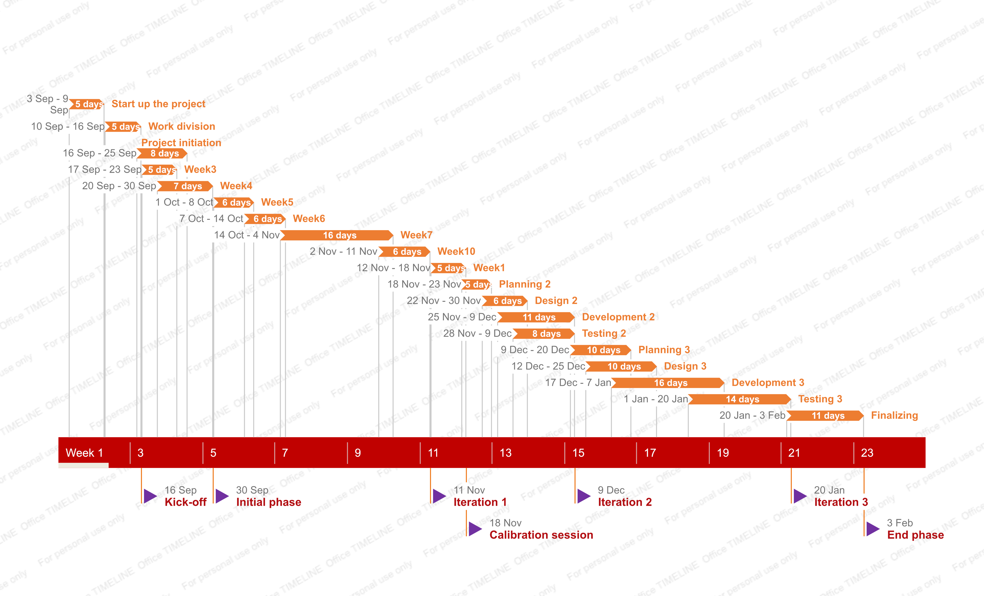

## Phase 1: Kick-off

##### Activity1: Start up the project

Tasks for the activity are:

* Start/Form groups
* Research airport luggage systems
* Come up with a proposal for an application
* Research on to be created algorithm
* Create a project plan draft
* Interview the client
* Discuss current situation, problems, desired end situation
* Set the project goal together with the client

Estimated duration is one week and 4 man hours.

Deliverables for milestone **M1** are:

* Concept version of the project plan
* Proposal for an application

##### Activity2: Work division

Tasks for the activity are:

* Organize the team
* Create concept version of URS
* Update concept version of the project plan
* Research on to be created algorithm

Estimated duration is one week and 5 man hours.

Deliverables for milestone **M1** are:

* Concept version of URS
* Final version of project plan

## Phase 2: Initiation

##### Activity3: Week3

Tasks for the activity are:

* Discuss project plan
* Create concept version of plan for iteration 1
* Updated version of project plan & URS

Estimated duration is one week and 4 man hours.

Deliverables for milestone **M2** are:

* Updated version of URS
* Concept version of plan for iteration 1

##### Activity4: Week4

Tasks for the activity are:

* Discuss URS & plan for iteration 1
* Updated URS & plan for iteration 1
* Create work division report

Estimated duration is one week and 4 man hours.

Deliverables for milestone **M2** are:

* Final version of plan for iteration 1
* Updated version of URS
* Work division report

|  |
| --- |
|  |

## Phase 3: Iteration 1

##### Activity5: Week5

Tasks for the activity are:

* Present URs to your tutor
* Discuss
* Update URS

Estimated duration is one week and 4 man hours.

Deliverables for milestone **M3** are:

* Updated version of URS

##### Activity6: Week6

Tasks for the activity are:

* Code
* Create concept version plan for iteration 2

Estimated duration is one week and 4 man hours.

Deliverables for milestone **M3** are:

* Concept version of plan for iteration 2

##### Activity7: Week7

Tasks for the activity are:

* Code
* Debug
* Update work division report

Estimated duration is one week and 4 man hours.

Deliverables for milestone **M3** are:

* Final URs for iteration 1
* Final version of plan for iteration 2
* Source code of proof of concept
* Proof of concept
* Updated version of work division

##### Activity8: Week10

Tasks for the activity are:

* UML Class diagram(s) & the non-trivial sequence diagram(s)

Estimated duration is one week and 4 man hours.

Deliverables for milestone **M3** are:

* UML Class diagram(s) & non-trivial sequence diagram(s) of proof of concept

## Phase 4: Calibration session

##### Activity9: Week1

Tasks for the activity are:

* Present proof of concept to board of tutors
* Calibration session about how to proceed
* Update URS
* Create design document

Estimated duration is one week and 4 man hours.

Deliverables for milestone **M4** are:

* There are no deliverables for this phase

## Phase 5: Iteration 2

##### Activity10: Planning

Tasks for the activity are:

* To be determined

##### Activity11: Design

Tasks for the activity are:

* To be determined

##### Activity12: Development

Tasks for the activity are:

* To be determined

##### Activity12: Testing

Tasks for the activity are:

* To be determined

Estimated duration is one week and 4 man hours.

Deliverables for milestone **M5** are:

* Final URS & design document
* Final version of plan for iteration 3
* Source code of prototype
* Unit tests of prototype
* Prototype
* Updated version of work division report

## Phase 6: Iteration 3

##### Activity13: Planning

Tasks for the activity are:

* To be determined

##### Activity14: Design

Tasks for the activity are:

* To be determined

##### Activity15: Development

Tasks for the activity are:

* To be determined

##### Activity16: Testing

Tasks for the activity are:

* To be determined

Estimated duration is one week and 4 man hours.

Deliverables for milestone **M6** are:

* Final URS & design document Final URS & design document
* Source code of final product
* Unit tests of final product
* Final product
* Final version of work division report
* Process report (including work division)

## Phase 7: End phase

##### Activity17: Finalizing the project

Tasks for the activity are:

* Final presentation followed by a final meeting about the marks.

Estimated duration is one week and 4 man hours.

Deliverables for milestone **M7** are:

* Final presentation